VIETNAM GENERAL CONFEDERATION OF LABOUR

**TON DUC THANG UNIVERSITY**

**FACULTY OF INFORMATION TECHNOLOGY**



**BIG ASSIGNMENT**

**Requirements Analysis and Design**

*Advised by*: **Ho Thi Thanh Tuyen**

*Authors*:  **Ngo Duc Huy – 522H0038**

**Dang Thanh Nhan – 522H0006**

**Vo Nhat Hao – 522H0090**

**Nguyen Thanh Nhan – 522H0051**

**HO CHI MINH CITY, 2024**

VIETNAM GENERAL CONFEDERATION OF LABOUR

**TON DUC THANG UNIVERSITY**

**FACULTY OF INFORMATION TECHNOLOGY**



**BIG ASSIGNMENT**

**Requirements Analysis and Design**

*Advised by*: **Ho Thi Thanh Tuyen**

*Authors*:  **Ngo Duc Huy – 522H0038**

**Dang Thanh Nhan – 522H0006**

**Vo Nhat Hao – 522H0090**

**Nguyen Thanh Nhan – 522H0051**

**HO CHI MINH CITY, 2024**

# ACKNOWLEDGMENT

We would like to express my sincere thanks to you, Faculty of Information Technology of Ton Duc Thang University.

In the process of studying and practicing at school, we have received a lot of attention from the teacher. She is the one who has guided and inspired us to study and help me in the most dedicated way. We would like to thank you for imparting to a lot of new and useful knowledge for our work in the future. We sincerely thank the teachers and especially Ms. Ho Thi Thanh Tuyen, who directly guided our in the learning process of Requirements Analysis and Design since we have not been exposed too much to the way we write the Essay, we cannot blame there will be mistakes. If there are any mistakes, we hope to be commented by you so that we can correct and complete as best as possible for the next time.

Finally, we would like to send kind words to you forgiving us the opportunity to work on our essay and improve our knowledge.

*Ho Chi Minh City, April 11, year 2024*

*Author*

*(Signature and full name)*

*Ngo Duc Huy  
 Dang Thanh Nhan  
 Vo Nhat Hao  
 Nguyen Thanh Nhan*

# THE REPORT WAS COMPLETED AT TON DUC THANG UNIVERSITY

I hereby declare that this is our own research work, conducted under the scientific supervision of Ms. Ho Thi Thanh Tuyen. The research contents and results in this topic are truthful and have not been previously published in any form. The data presented in tables and figures, serving for analysis, comments, and evaluations, are collected by the author from various sources, clearly referenced in the reference section.

Furthermore, the project also incorporates some comments, evaluations, as well as data from other authors, and different organizations, all of which are appropriately cited and referenced.

**If any misconduct is discovered, I take full responsibility for the content of my project.** Ton Duc Thang University is not liable for any copyright infringements or violations caused by me during the implementation process (if any).

*Ho Chi Minh City, April 11, year 2024*

*Author*

*(Signature and full name)*

*Ngo Duc Huy  
 Dang Thanh Nhan  
 Vo Nhat Hao  
 Nguyen Thanh Nhan*

# TABLE OF CONTENTS

ACKNOWLEDGMENT i

THE REPORT WAS COMPLETED AT TON DUC THANG UNIVERSITY ii

TABLE OF CONTENTS iii

TASK 1: USE CASE DIAGRAM 1

1.1 General use case 1

1.2 Decomposition use case 1

1.2.1 Use case Sign in 1

1.2.2 Use case Place order 2

1.2.3 Use case manage Shopping cart 2

1.2.4 Use case Search products 3

1.2.5 Use case Manage category 3

1.2.6 Use case Manage order 3

1.2.7 Use case Manage customer 4

1.2.8 Use case Control debt 4

1.2.9 Use case Manage inventory 5

1.2.10 Use case Report 5

TASK 2: ACTIVITY DIAGRAM 6

2.1 Activity Diagram Sign in 6

2.2 Activity Diagram Search products 7

2.3 Activity Diagram Manage shopping cart 8

2.4 Activity Diagram Manage category 9

2.5 Activity Diagram Manage order 10

2.6 Activity Diagram Manage customer 11

2.7 Activity Diagram Control debt 12

2.8 Activity Diagram Manage inventory 13

2.9 Activity Diagram Report 14

TASK 3: CLASS DIAGRAM 15

TASK 4: SEQUENCE DIAGRAM 16

4.1 Sequence Diagram Sign in 16

4.2 Sequence Diagram Forgot password 17

4.3 Sequence Diagram Manager customer 18

4.4 Sequence Diagram Search product 19

4.5 Sequence Diagram Payment 20

4.6 Sequence Diagram Report 21

4.7 Sequence Diagram Place order 22

4.8 Sequence Diagram Manager debt 23

4.9 Sequence Diagram Manager inventory 24

4.10 Sequence Diagram Manager order 25

4.11 Sequence Diagram Manager category 26

TASK 5: DATABASE MODEL 27

5.1 ERD 27

5.2 Relational Schema 28

REFERENCES 29

# TASK 1: USE CASE DIAGRAM

## https://lh7-us.googleusercontent.com/TUmGR17gw7cA_4gNGcuKwzr3P1Se6pavm-zaD0gJ4dpZtnKg3TajNHUehNFLQxH7u1pGPzd1VsZ6DUaOzlnsHV1bMINuhmDdDy5U5xTuYVpmliAe-hpsyoc0r992WIl6AocLOEOmQCasd2I=s2048General use case

## Decomposition use case

### https://lh7-us.googleusercontent.com/BsRyAO3VO4bxxMpQJ7GGHp8b72DrkVBA7ad6CCOuZVymIOhyJBqyCS92gAm-EGoFazYZR-y0kipMN4xBUz-Y4iFpFSXage9HcNWgx8kotH7OpCH68VkgBFdCDTlPAi03DOmKwSAiVmaRArM=s20481.2.1 Use case Sign in

### https://lh7-us.googleusercontent.com/5SjoxYuPC7jlCXsbtbS4QAykEEaOzavje3vihbbGvVex5AL202IqM3pJJ3A499KfY4shWCRgNLUOBSzL9LU2E31tGclyzMczLsUU7akVycItMmE2LMyMBavLLtUNX8vwLs3wHpwtSCrVC1A=s20481.2.2 Use case Place order

### https://lh7-us.googleusercontent.com/iU8gEvHgDEnfVAxvOM5vz5vj6B32kzxPQX0-yH53mae1hOe9_zKdnspl_Dzz8aJKrfikLqzpguTD9CSe4vfz4D3d97zW2vrIuvCRwUuqGcC3RoY3magDm4Jl_qcEkbl8yipDUEqnpiNWMwg=s20481.2.3 Use case manage Shopping cart

### https://lh7-us.googleusercontent.com/4kAcnkts10t37VRvIQSfJlRluVZ5aOiMZsJzWPHkM1SSxUG0tWr-dP0wV-0y__GC4Tp4rHf_Q1t0rMETgnuClklHLetqmNbSXrGqCeeLaVf194UEWiHsKsAbVki9jl3846vSUyJUHwMhrfw=s20481.2.4 Use case Search products

### https://lh7-us.googleusercontent.com/1gWwtaI5pOvWsBBCYO1ZFCtGc3egcr0C_CeRZlAxeg8g_KfJEx8PbT2tv8aa0w9JOkgpbOsmbwfEB50HRICzsB0NV0-ooxGFr_ZV_WifCzdc5OcVIkCNN41nxuYfNiXOflRC3RdynU6ag7Y=s20481.2.5 Use case Manage category

### https://lh7-us.googleusercontent.com/Vn026sDa3Tl9hMUkiKhHa5icEU6xYuVmZTK6fQDYf84d0l_zHwnAQIzegOm0G51Z2ZJEsSgkUDbzQ7UK-zA3Tbmg6NkIR0b1jRo4L3wAq2bUFZUDS4yDYg2X0Q89B-iFREU3ey1bYUdtP8I=s20481.2.6 Use case Manage order

### https://lh7-us.googleusercontent.com/n3B3-XfYu_-TjkTyiplESwvPymghkoRZqSek3LEPKxarooJfW4KT3EXa4puTQOORP9sMQEZr4LhXKtBuUr8baKLKCKil2EnsznOWtpwiMAA7gn8WiF76Y8YPa9t0Q_mv1N98g3aVIGCbrs8=s20481.2.7 Use case Manage customer

### https://lh7-us.googleusercontent.com/feJ_vW9PYe24VmBKP7oUgobnWzfPAfGsCM40VRYMT5uyH5Guq8vUPf_uGG29o8zs2fvfQiWortgY7Wsktqj18xnNRIqazqDYVtJJ45WlhD5VZUt1OczYo6HNIDCygdjAJ3fR12dmJIjtN7Q=s20481.2.8 Use case Control debt

### https://lh7-us.googleusercontent.com/zM48NL614a5wykdSVmDBV-u_UpCwF08UCd_PIGUvIIO4ZTnXkZjsjp0U5VJl9UzYh0IPwxEFDzZBeOav8PGMPU0QsK5IBpuHUV2vOvxOG1cfjIv6DkidQMJAxw6QRV9co6fn2xNI8WszXLs=s20481.2.9 Use case Manage inventory

### https://lh7-us.googleusercontent.com/Pk7AQ5qvYSd5ejBjD7g49qPI1KovO8X3qExLvCZXPoium3iK_kLuDuFEB3_rUt8fgZAx3Vdifn5QarJu5fKQg5F3SsE5DYA-m_0Pve2mnLBrJ714G0lwkhzPo6Bzr99whyZ6UPJcrah38Is=s20481.2.10 Use case Report

# TASK 2: ACTIVITY DIAGRAM

1. 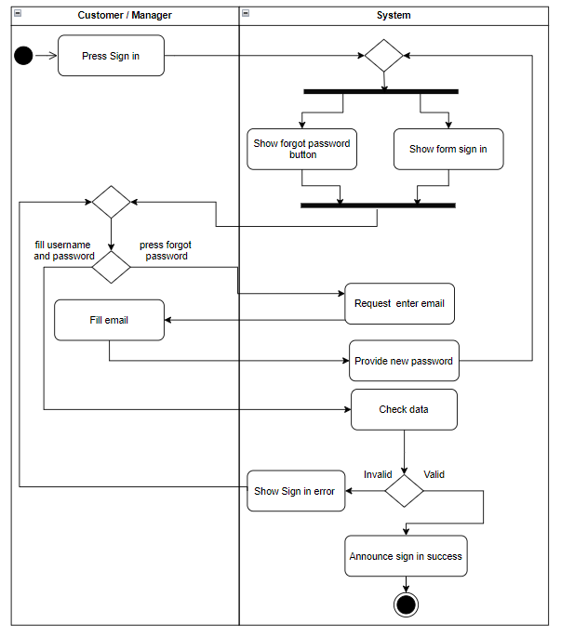

## Activity Diagram Sign in

## Activity Diagram Search products

## Activity Diagram Manage shopping cart

## Activity Diagram Manage category

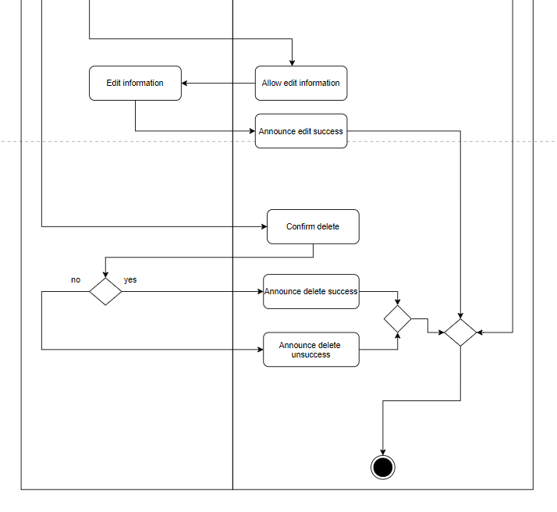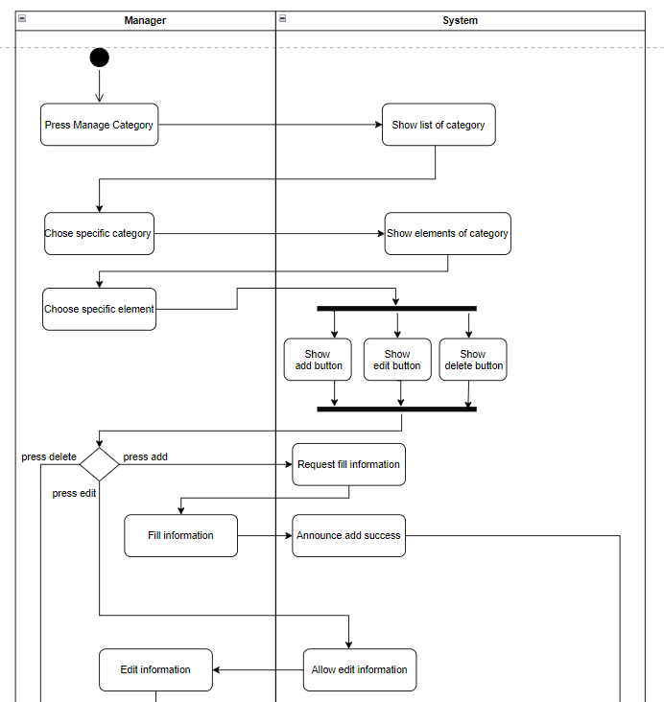

## Activity Diagram Manage order

## Activity Diagram Manage customer

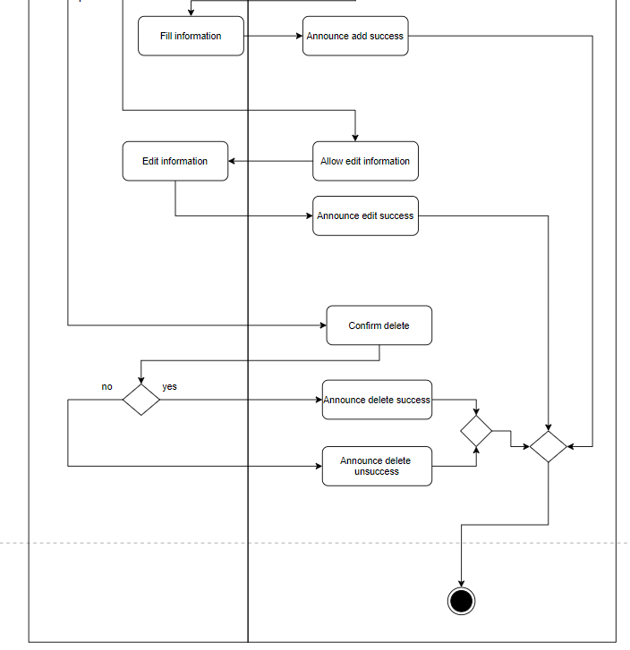

## Activity Diagram Control debt

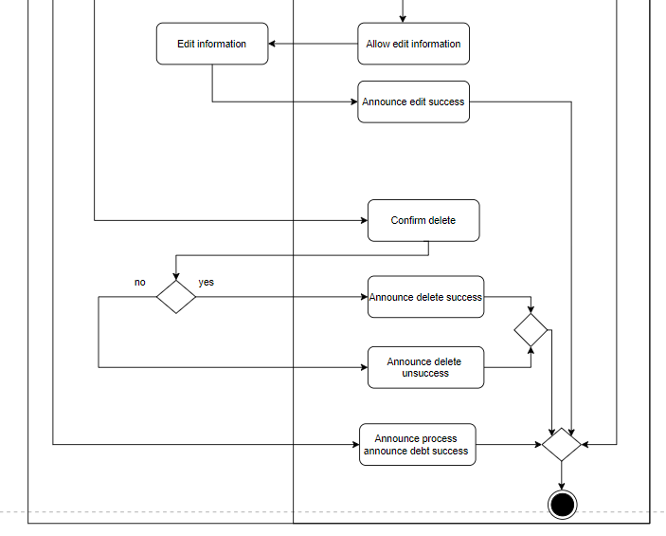

## Activity Diagram Manage inventory

## Activity Diagram Report

# TASK 3: CLASS DIAGRAM

# TASK 4: SEQUENCE DIAGRAM

1. 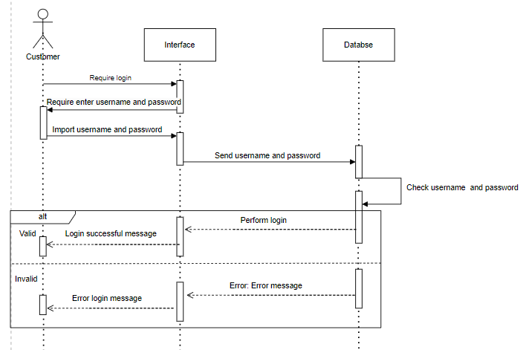

## Sequence Diagram Sign in

## Sequence Diagram Forgot password

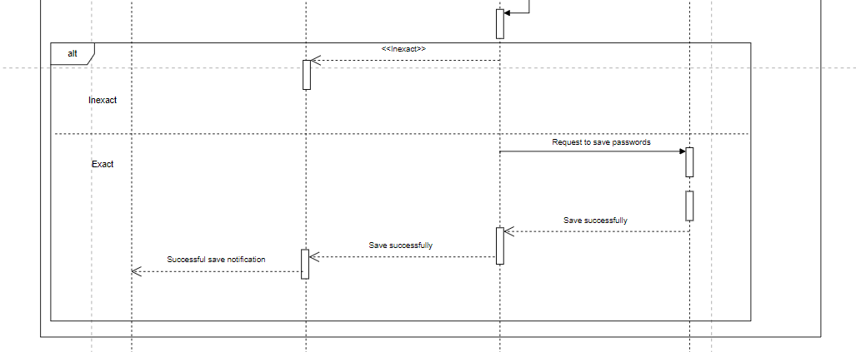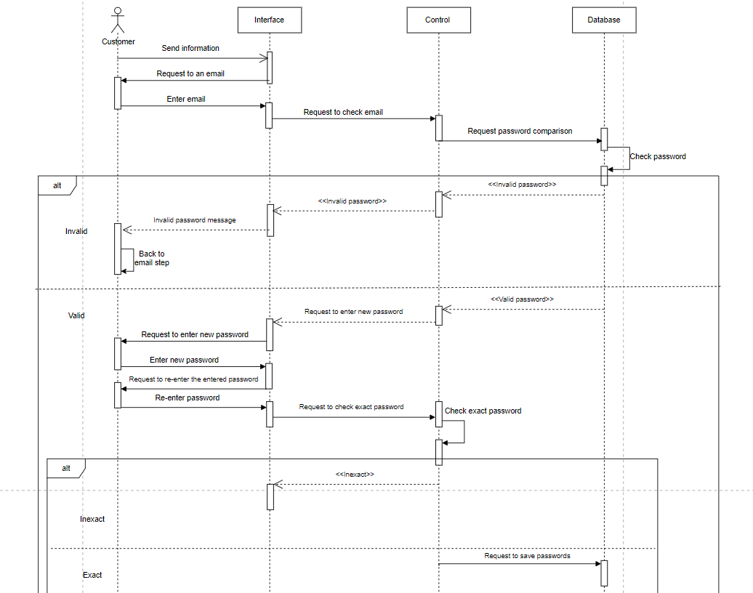

## Sequence Diagram Manager customer

## Sequence Diagram Search product

## Sequence Diagram Payment

## Sequence Diagram Report

## Sequence Diagram Place order

## Sequence Diagram Manager debt

## Sequence Diagram Manager inventory

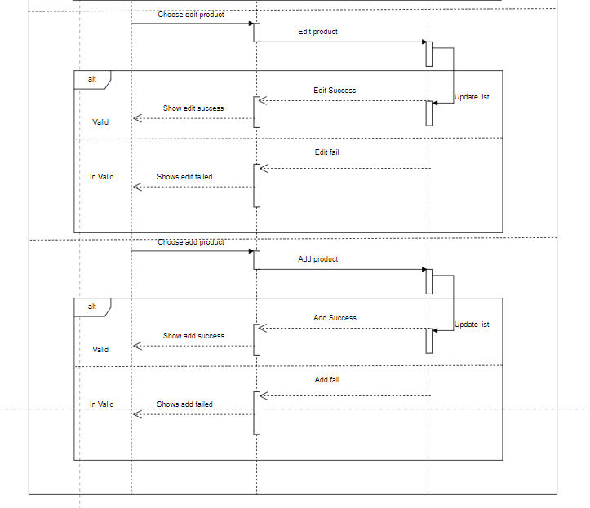

## Sequence Diagram Manager order

## Sequence Diagram Manager category

# TASK 5: DATABASE MODEL

1. 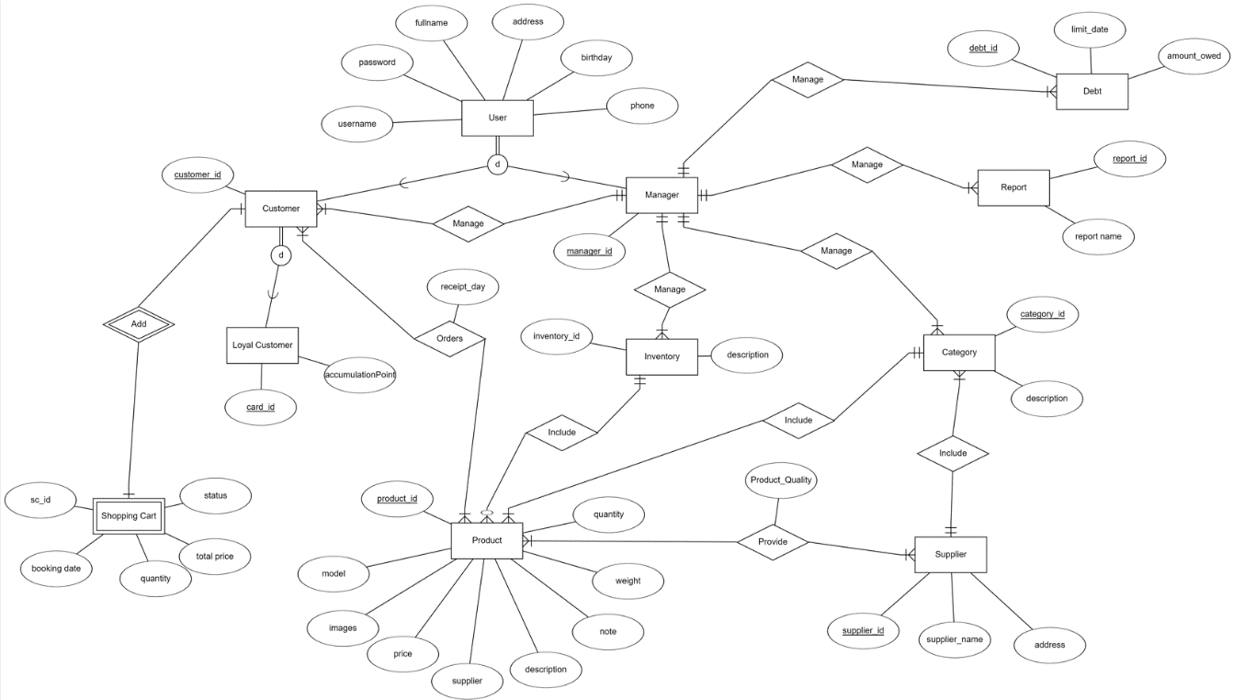

## ERD

## Relational Schema

# REFERENCES

* Use Case: <https://creately.com/guides/use-case-diagram-tutorial/>
* Activity Diagram: <https://creately.com/guides/activity-diagram-tutorial/>
* Class Diagram: <https://www.visual-paradigm.com/guide/uml-unified-modeling-language/uml-class-diagram-tutorial/>
* Sequence Diagram: <https://creately.com/guides/sequence-diagram-tutorial/>